EXAMPLE 1

Joe College is a full-time sophomore at UNC-Asheville majoring in Atmospheric Sciences. His parents provided more than half of his support and he lived with them when not at school. Joe worked part-time during the summer and earned $7,500, which was less than half of his support. Joe has never been convicted of a felony and his parents have claimed the AOC on one prior return. He spent $7,000 on room and board, $200 for a parking pass, and $550 on books and supplies that he purchased on the internet. The scholarship was a Pell Grant.

Joe received the following 1098-T from UNCA.

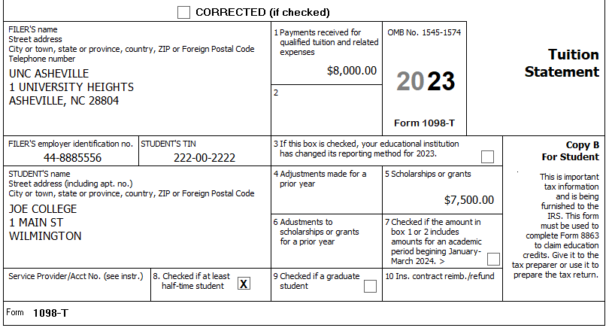

The following shows the relevant AOC Workbook entries for this example.
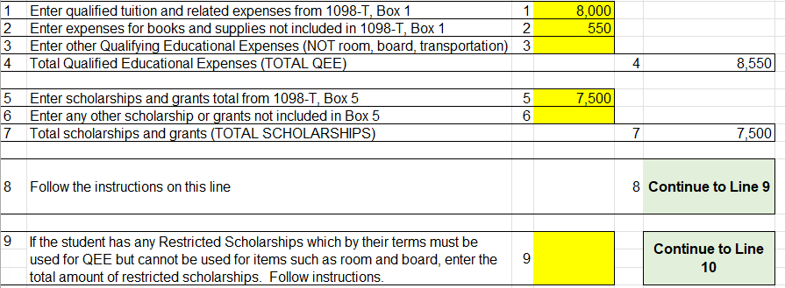
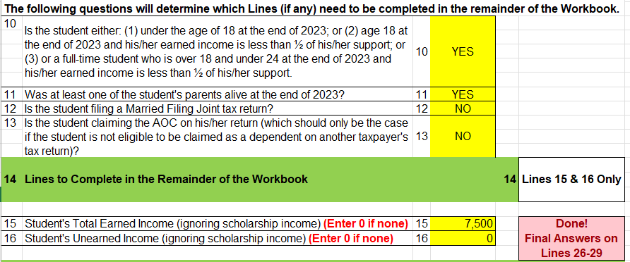
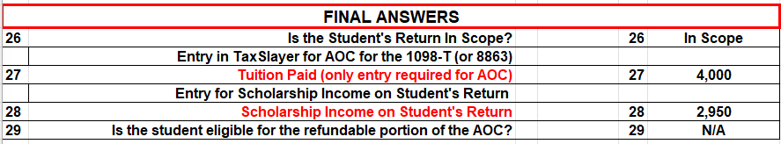

Example 2
Ann is 28-years old, Single, with no kids, and works at a job in Jacksonville where she earned $30,000. She is attending Coastal Carolina Community College at night and on the weekends to obtain an Associate Degree in Nursing. She has only had one prior year of school after high school. She supports herself. Her 1098-T shows $2,500 of qualified educational expenses. Box 5 shows a scholarship of $5,000, which she tells you was a Pell Grant (which is an unrestricted scholarship). She also spent $1,500 on books for the year.

She qualifies for the AOC. Because the amount of her qualified expenses of $4,000 ($2,500 Box 1 plus $1,500 for books) is less than her scholarship of $5,000, we must use the Workbook.

The following shows the relevant AOC Workbook entries for this example.
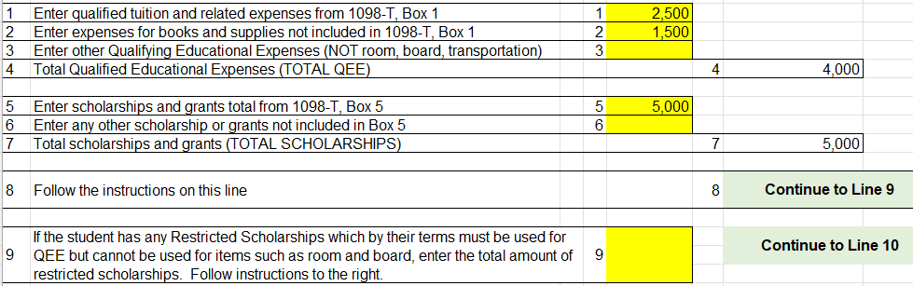

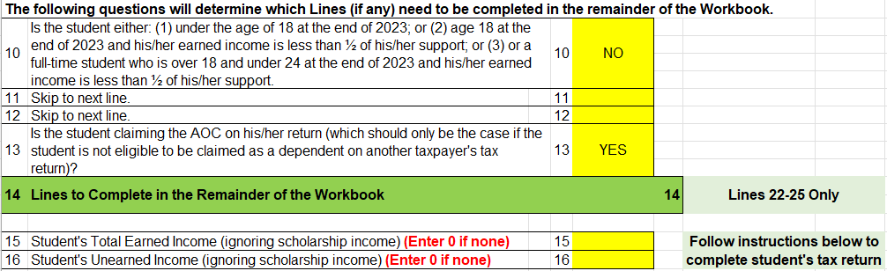

Next, we need to go to the Instructions for completing the student’s tax return.

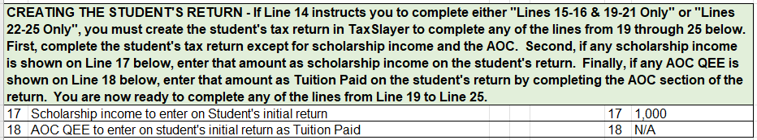

We first need to complete Ann’s return other than any education credit or scholarship income. After completing her return, the Workbook instructions tell us that we need to add the amount shown on Line 17 as scholarship income to her return before proceeding with the Workbook.

In her return, go to Income/ Other Income/ Other Compensation/ Scholarships and Grants and enter the $1,000.

We then go back to the Workbook to complete Lines 22-25.

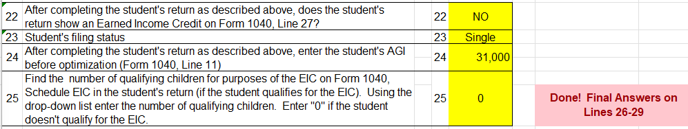

The Workbook then provides the final answers.

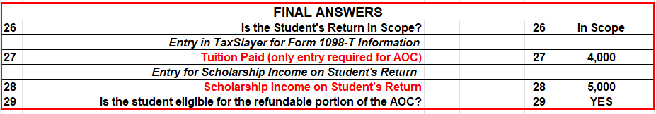

Prior to using the Workbook, Ann owed Federal tax of $1,841 on her $30,000 of wages and $1,000 of scholarship income.

By using the Workbook, even though we added an extra $4,000 of scholarship income to her return, she went from owing $1,841 to getting a refund of $179, for a savings of $2,020.

